This guide will help you apply for a VETDSS course at SM TAFE as a new student. Follow these steps carefully to make sure your application is complete and ready to go!

**What You’ll Need Before You Start**

Make sure you have the following ready:

* **WA Student Number (WASN)** – This is your 8-digit school ID (ask your VET Coordinator if you’re unsure).
* **Unique Student Identifier (USI)** – Get yours at <https://www.usi.gov.au/>
* **Parent/Guardian Contact Info** – Email and mobile number.
* **OLNA Report** – If you’ve done OLNA, include your results.
* **Your Last Two School Reports** – PDF format preferred. A “C” grade or higher in English and Maths is ideal.
* **Resume, References and Certificates** – Anything that shows your skills or achievements.
* **Student Statement** – Write up to 1000 characters explaining why you want to do the course.
* **Note for Year 10 Students** – You can only apply for Certificate II level courses.

**Tech Tips – Getting Set Up to Apply**

To ensure your application process goes smoothly:

* Use Google Chrome – it works best with the application portal.
* Use your own device (like a personal laptop or tablet), if possible.
* If you're using a school device, you have two options:
  + Open the “Apply Now” link by selecting “Browse as Guest”, or
  + Use this alternative Apply Now link: [Apply Now – Link 2](https://login.microsoftonline.com/tafe.wa.edu.au/oauth2/authorize?client_id=0ec188d7-ff34-4dc9-a9f7-5fb41b8a1cdf&redirect_uri=https://smtafe.t1cloud.com/T1Default/CiAnywhere/Web/SMTAFE/LogOn&scope=user.read&response_type=code&login_hint=%5bStudentNumber%5d@tafe.wa.edu.au)
* Make sure your internet connection is stable before starting.
* Have all your documents saved and ready to upload in PDF format.

**Upload Everything at Once**

You must upload all documents when you apply. Once submitted, you can’t go back and edit your application.

**School Endorsement**

Your school needs to support your application before it goes to the selection panel. Final decisions will be shared with schools in October.

**Final Tips**

* VETDSS courses are very competitive.
* Include as much supporting evidence as you can.
* Make sure your documents are clear and complete.

**New Student Registration**

This application process is for new students who have never previously attended any SM TAFE program or delivery. You are considered a new student if you have not participated in any of the following:

* Try-a-Trade days
* Year 9 Taster programs
* Any previous SM TAFE course, workshop, or short program

*If you have attended any of the above, you are considered an existing student. Please refer to the Existing Student Application Guide for instructions on how to apply.*

**Start Your Application**

Click the following link to create your SM TAFE account and begin your application: [Apply Now](https://smtafe.t1cloud.com/T1Default/CiAnywhere/Web/SMTAFE/StudentCore/StudentApplicationRegistrationMyMaintenance?f=%24SC.STUAPPREG.MNT&suite=SM&G=071dc873-d974-41f1-bac5-a41c961ad3cd)

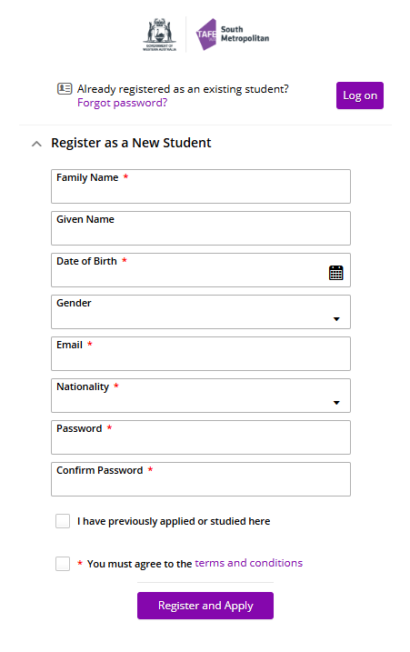Before proceeding, please read the instructions below carefully.

**Important: New Student Login**

As a new student, you do not yet have an SM TAFE Student ID, so please do not attempt to log in.  
Instead, select “Register as a New Student” to begin your application.

**Registration Instructions**

1. Fill in all required fields
2. Agree to the Terms and Conditions
3. Click Register to complete your account setup

**Important Notes**

* Your Given Name and Family Name must match your legal name as recorded by your school.
* Your password must meet the following criteria:
  + Minimum of 14 characters
  + Must include at least:
    - One uppercase letter
    - One lowercase letter
    - One number
* All fields marked with an asterisk (**\***) must be completed and the “I agree to the Terms and Conditions” checkbox must be selected in order to proceed to the application portal screens.
* After registering, you will receive a confirmation message on screen, as well as a confirmation email sent to the email address you provided. This email will include your SM TAFE Student ID and an acknowledgement of your application.

**Unable to Register as a New Student?**

If you are unable to register and receive an error stating that another person with the same details has already registered, it’s possible that:

* You may have previously been registered with SM TAFE
* Someone with similar details already exists in our system.

If this occurs, please email the following information to [vetdss@smtafe.wa.edu.au](mailto:vetdss@smtafe.wa.edu.au) so we can manually create a Student ID for you or locate your existing ID:

|  |  |
| --- | --- |
| First Name | *Your given name* |
| Middle Name | *Your middle name (if applicable)* |
| Surname | *Your family name* |
| Address | *Your current residential address* |
| Date of Birth | *Format: DD/MM/YYYY* |
| Email Address | *A valid email you check regularly* |
| Nationality | *Your nationality* |
| Gender | *Your gender identity* |
| Country of Birth | *The country where you were born* |

**Course/s Selection**

To find the course you want to apply for, type the course code into the search bar and press Enter. The course code can be found in the 2026 [2026 Course List](https://www.southmetrotafe.wa.edu.au/sites/default/files/2025-06/SMTAFE-VETDSS-2026-Course-List_A4.pdf) and/or [Course Guide](https://www.southmetrotafe.wa.edu.au/sites/default/files/2025-06/SMTAFE-VETDSS-2026-Course-Guide.pdf)

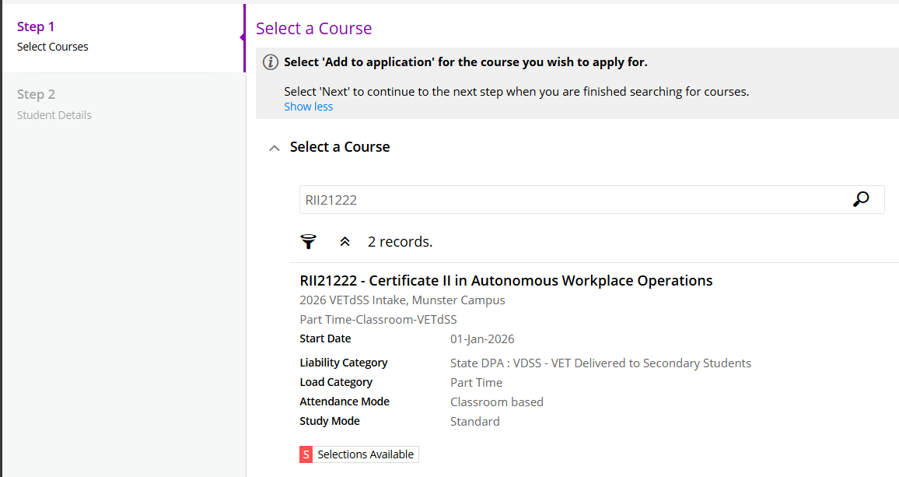

**IMPORTANT**: When selecting a course, you **MUST** ensure that the description includes “2026 VETDSS”.

Please also double-check that the campus you select is the one you intend to attend.

**Next Steps:**

Once you’ve found your course, click “Add to application” located at the bottom right-hand side of the course listing.



If you wish to select another course, click “Select another course” and use the search box as described in the previous instructions.



**Important information:**

* You may select a **maximum of two courses**.
* Any additional selections beyond two will be automatically disregarded.
* A third preference will **NOT** be accepted, so please choose carefully.

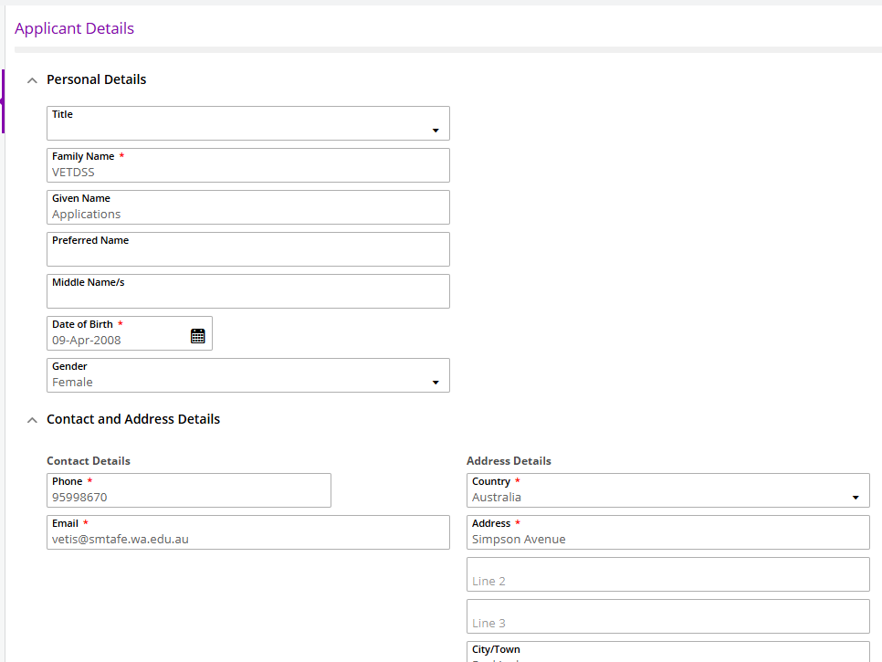**Applicant Details**

Fill out all mandatory fields, which are marked with a red asterisk (*). These will include your:

* Personal details
* Contact and address information
* Nationality and citizenship details
* Disability information

*If you selected "Yes" for Disability Details, you must choose a condition in order to proceed.*

*If you have a condition that is not formally diagnosed but would still like us to be aware of it, please select "Other."*

Once all fields are completed, click “Next” to continue.

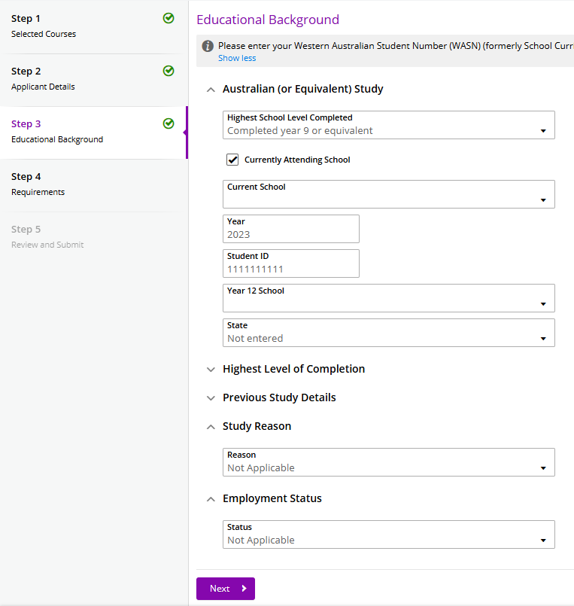**Educational Background**

Not all mandatory fields in this section are marked with an asterisk (*), but they still need to be completed. These include:

* Australian (or equivalent) study
* Study reason
* Employment status
* Student ID field – you will need to enter your WASN (SCSA) number here.

Mandatory fields are circled in the screenshot provided.

Once completed, click “Next” to continue.

**Requirements**

Not all fields in this section are mandatory. Mandatory fields are clearly marked as “Mandatory”, while optional fields will be indicated as “Optional.”

Please refer to the screenshot provided for visual guidance.

Note for Year 9 Students: Year 9 students may apply for next year. Use your Semester 1 reports and enter the subject level for Maths and English as:

“N/A – Year 9”, along with your Semester 1 grades.

For fields marked as Mandatory, click “Respond.” You will then be required to:

* Answer the specific question
* Upload any supporting documents, if required
* Click Save. Once saved, the response will turn purple and display “**RESPONSE RECEIVED**”
* You may edit any responses before clicking Next
* 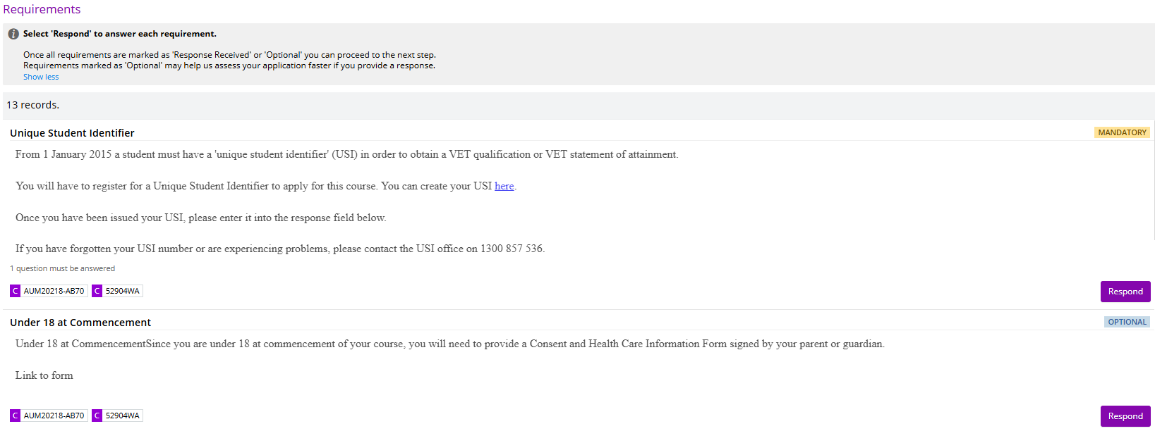Once completed, click “Next” to continue

**Final Step: Review and Submit Your Application**

You are now ready to review your application and submit it. Before submitting, please double-check the following:

* Your legal name is entered correctly
* Your date of birth is accurate
* Your email address is correct
* Your course and campus selection are correct

Once confirmed, click Submit in the top right-hand corner of the screen.

**IMPORTANT: ONCE YOUR APPLICATION HAS BEEN SUBMITTED, IT CANNOT BE CHANGED.**

A confirmation email will be sent to your provided email address. Please check your junk or spam folder if you do not see it in your inbox.

If you do not receive a confirmation email, contact South Metropolitan TAFE at: [vetdss@smtafe.wa.edu.au](mailto:vetdss@smtafe.wa.edu.au)

If you experience any issues with your application, please refer to the VETDSS Application Troubleshooting Guide, located on SM TAFE’s VETDSS website.

**Good luck with your application!**

We wish you all the best in your educational journey and hope this opportunity opens exciting doors for your future.