**Introduction**

This user guide provides step by step instructions on how to apply for a VETDSS course for 2025. To complete the application, you will need:

* **Google Chrome is the preferred browser when completing an application.**
* This portal works best on your personal device than a school device.
* If you are using school device, browse the “Apply now” link using “browse as a Guest”.
* As you are a current student with SM TAFE, please ensure you have your SM TAFE ID to login.
* Once you have registered or logged in, you will require the information below to complete the application
* WA Student Number (WASN) [formerly known as SCSA] this is an eight-digit number that can be found on your school report or ask your school VET Coordinator if unsure.
* A Unique Student Identifier (USI) – if you don’t have one, please visit

<https://www.usi.gov.au/> . This is 10 characters long.

* [Parent or](http://www.usi.gov.au/%3B) guardian email address and mobile number.
* OLNA (Online Literacy and Numeracy Assessment) report (if applicable)
* Your last two school reports in electronic format ie.PDF (“C” Grade in Mathematics and English is preferred. However, all applications will be considered.
* Resume, references, and any certificates which will help support your application.
* A student statement outlining why you should be selected to participate in the course (limit of 1000 characters).
* **Year 10 students are only eligible to apply for Certificate II level courses.**
* Note: once your application is submitted, you will be unable to review or edit

VETDSS courses are extremely competitive. It is recommended that as much evidence is provided to support your application. These documents must be uploaded at the time of application.

Your school will need to endorse and support the application before the selection process begins. Outcomes of selections will be announced to schools in October.

# **Currently Enrolled students – who are currently enrolled and studying at**

# **SM Tafe and HAVE an SM Tafe Student ID number and active Office 365 account (30######)**

If you meet any of the criteria mentioned above, have your SM TAFE Student ID and the password you previously set up ready, and then follow the steps outlined below.

**DO NOT USE** your SCSA number or any other TAFE number. It MUST be SM TAFE Student ID number starting with a **30XXXXXX (eight-digit ID).**

**We suggest that you use your personal device (not a school device).**

**If you are using school device, browse the “Apply now” link using “browse as a Guest”.**

**Google Chrome is the preferred browser when completing an application.**

### **STEP 1**

[Apply now - Link 2](https://login.microsoftonline.com/tafe.wa.edu.au/oauth2/authorize?client_id=0ec188d7-ff34-4dc9-a9f7-5fb41b8a1cdf&redirect_uri=https://smtafe.t1cloud.com/T1Default/CiAnywhere/Web/SMTAFE/LogOn&scope=user.read&response_type=code&login_hint=%5bStudentNumber%5d@tafe.wa.edu.au)

Click the “Apply now” click and click “Log on”.

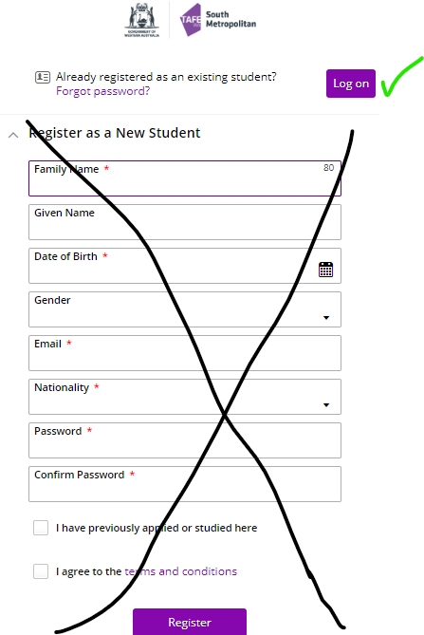



**Do not type anything here. Just click the “Log on” button.**

**STEP 2**

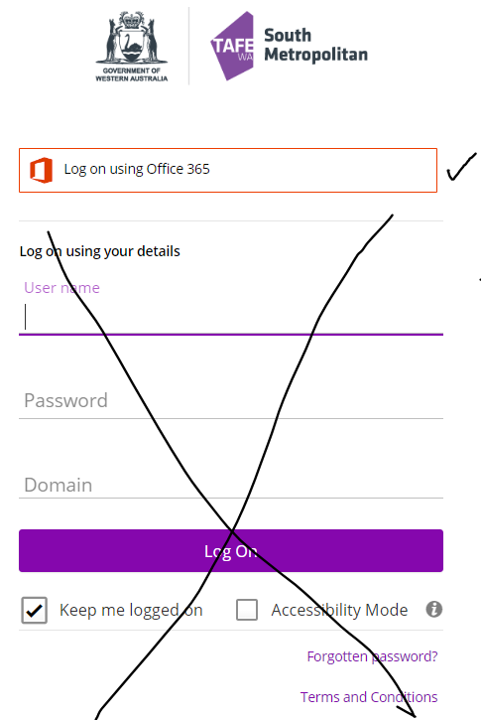



**Do not type anything here. Just click the “Log on using Office 365” button.**

If you are using school Laptop, the above prompt might automatically take you to **Error message** .

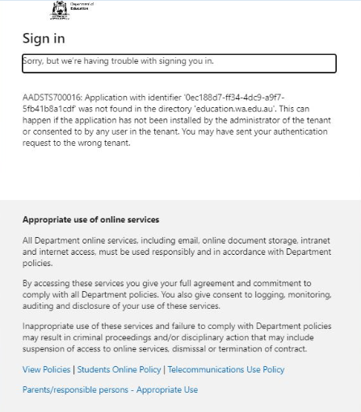

If that’s the case, we suggest the following options to eliminate the error message:

* Where possible, please use your personal device (not a school device) or
* If you are using school device, browse the “Apply now” link using “**browse as a Guest**”.

Copy paste the below link to the search bar in the **Guest browser** and click ENTER

[Apply now - Link 2](https://login.microsoftonline.com/tafe.wa.edu.au/oauth2/authorize?client_id=0ec188d7-ff34-4dc9-a9f7-5fb41b8a1cdf&redirect_uri=https://smtafe.t1cloud.com/T1Default/CiAnywhere/Web/SMTAFE/LogOn&scope=user.read&response_type=code&login_hint=%5bStudentNumber%5d@tafe.wa.edu.au)

or

If you are using school device, using the following link which will prompt you to Pick the SM TAFE account

[Apply now - Link 2](https://login.microsoftonline.com/tafe.wa.edu.au/oauth2/authorize?client_id=0ec188d7-ff34-4dc9-a9f7-5fb41b8a1cdf&redirect_uri=https://smtafe.t1cloud.com/T1Default/CiAnywhere/Web/SMTAFE/LogOn&scope=user.read&response_type=code&login_hint=%5bStudentNumber%5d@tafe.wa.edu.au)

### **STEP 3**

Sign into TAFE account by typing your TAFE email address:

E.g., [30XXXXXX@tafe.wa.edu.au](mailto:30XXXXXX@tafe.wa.edu.au)

Enter your password.

Pick your SM TAFE account from the list below:

If you are applying for a course with SM TAFE,you **MUST** choose your SM TAFE Student ID number starting with a **30XXXXXX (eight digit ID)@tafe.wa.edu.au**

E.g. [30XXXXXX@tafe.wa.edu.au](mailto:30XXXXXX@tafe.wa.edu.au)

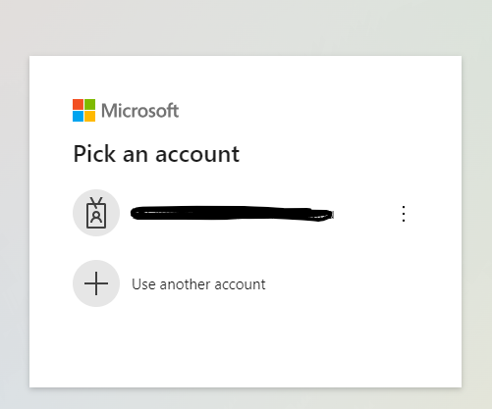

If your SM TAFE account doesn’t appear in the list above, click on “Use another account”. Type your SM TAFE email address. E.g. [30XXXXXX@tafe.wa.edu.au](mailto:30XXXXXX@tafe.wa.edu.au)

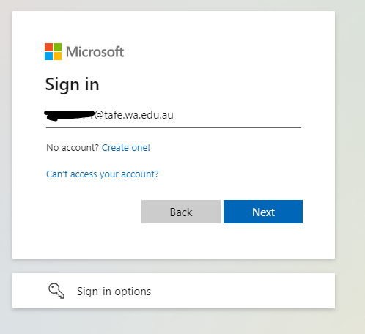

Enter Password:

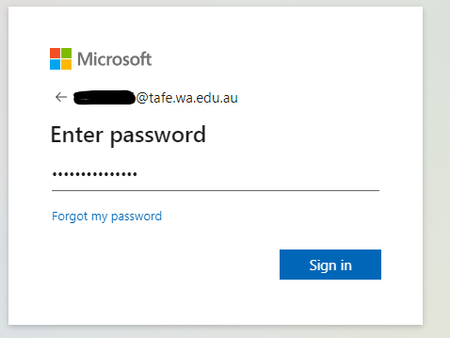

#### Don’t remember your password?

#### If you don’t remember your password, you can access the registered email, the “Forgot my password” link can be used.

#### If this is not successful, VETdSS team can reset a temporary password and the Log in process can be reattempted.

Please email [vetdss@smtafe.wa.edu.au](mailto:vetdss@smtafe.wa.edu.au) with your **FULL NAME, DATE OF BIRTH**, your **SM TAFE ID** number starting with a **30XXXXXX (eight digit ID)** and we will arrange to change your password for you. Once your password has been updated and you are logged in, you may continue with the below steps.

### **STEP 4**

The next step will take you to the Microsoft Authenticator code/number and you need to open the Microsoft Authenticator APP in your phone to enter the Authenticator number showing in your computer and follow prompts.



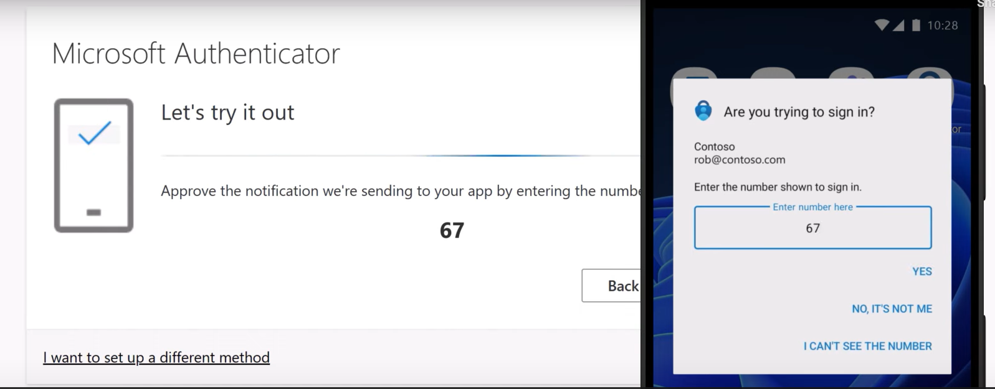

If you did not set up the Authenticator, please [click here](https://www.southmetrotafe.wa.edu.au/current-students/manage-your-sm-tafe-microsoft-365-student-account) for further instructions to on how to set up the Microsoft Authenticator & Multi-Factor Authentication (MFA) .

Once you have successfully verified the access using Microsoft Authenticator APP, you will see a similar screen like the one below.

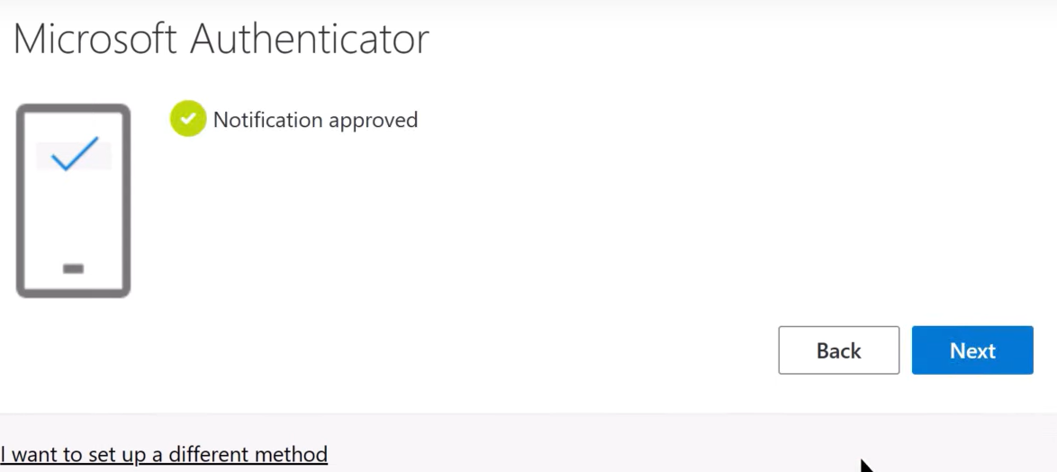

**Click NEXT**

### **STEP 5**

**YOU ARE NOW READY TO MAKE AN APPLICATION**

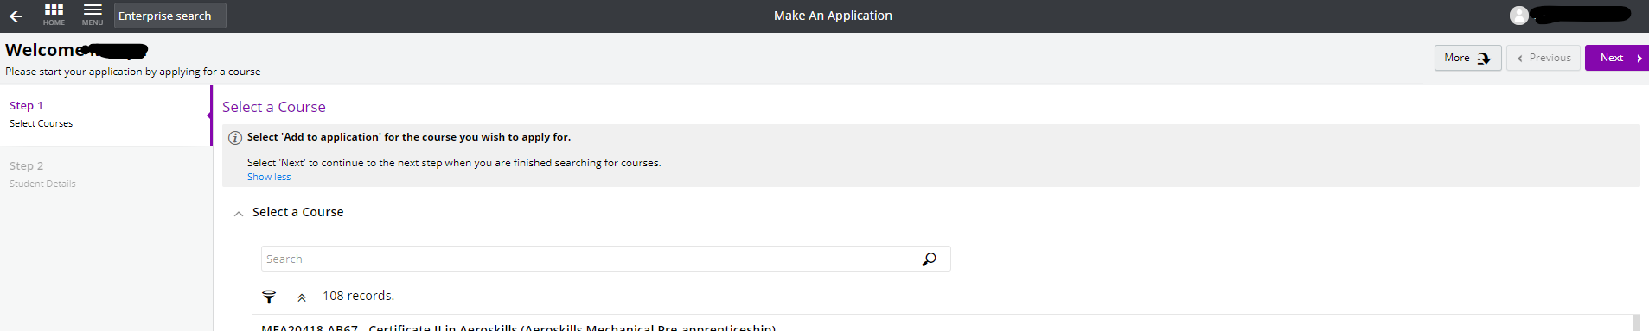

# **How to complete an application**

### **Course Selection**

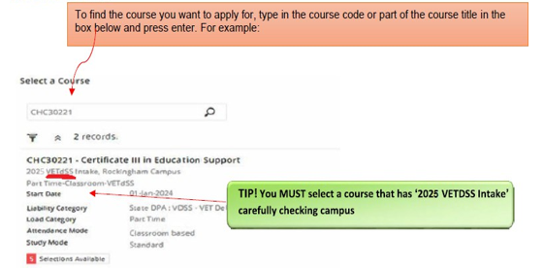

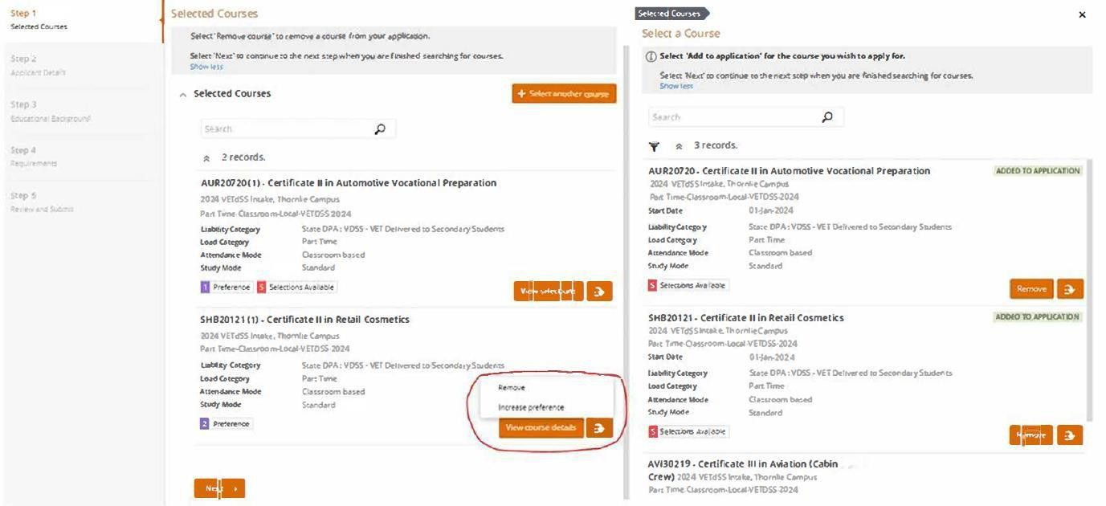



Once you have found your course, click ‘Add to application”. If you wish to select another course, you can click on “Select another course” and use the search box as used in previous instruction. (Maximum selection are 2 courses; any others will automatically be disregarded).

Click

to continue.

**A 3rd preference for a course will NOT be accepted.**

### **Applicant Details**

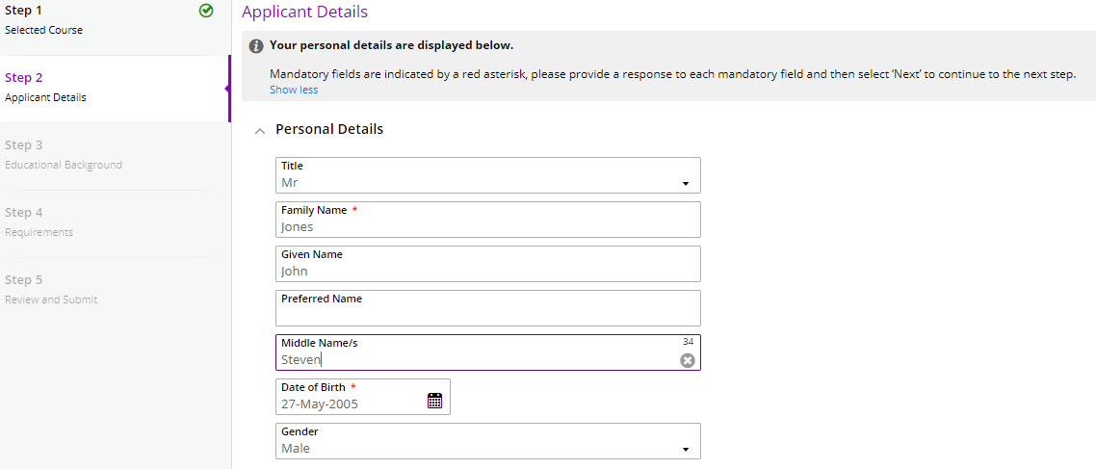

Fill out all mandatory fields (see table below) which are marked with a red asterisk * Once completed, click to continue.

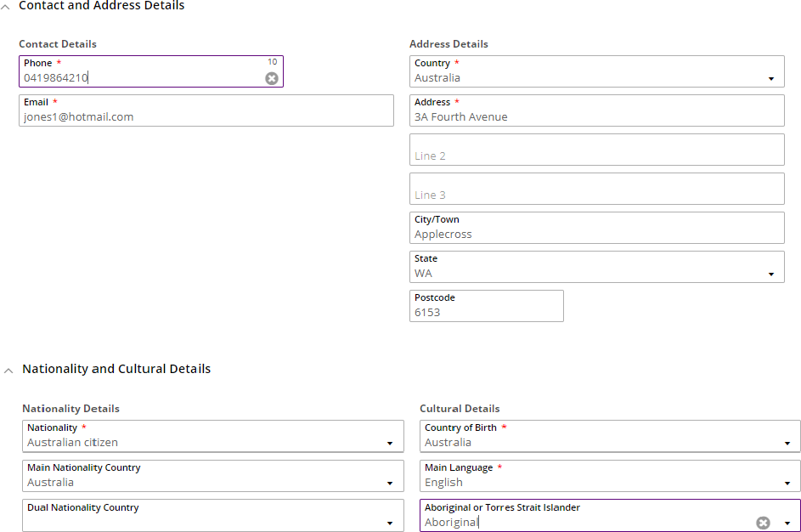



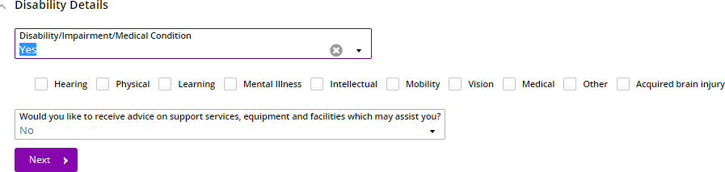

### **Educational Background**



Not all fields in this section are mandatory. Mandatory fields are highlighted below. Once completed, click to continue.

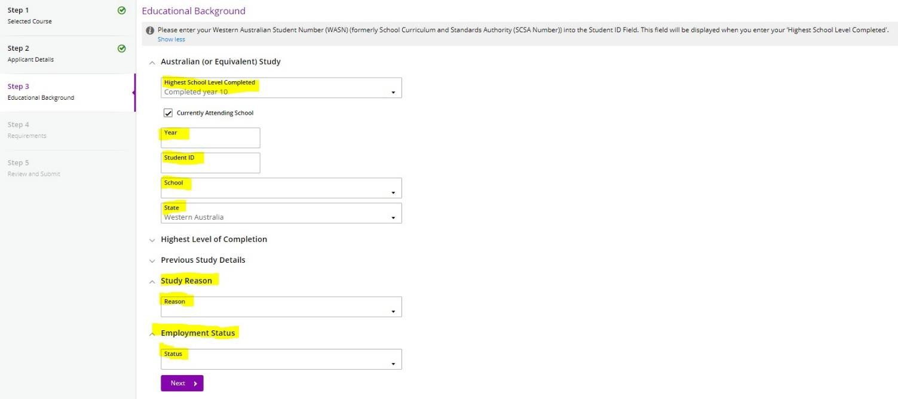

In this field, please enter your Western Australian Student Number (WASN) / SCSA Number this is an eight-digit number.



If unable to update educational background, contact VETDSS via email at [vetdss@smtafe.wa.edu.au](mailto:vetdss@smtafe.wa.edu.au)

### **Requirements**

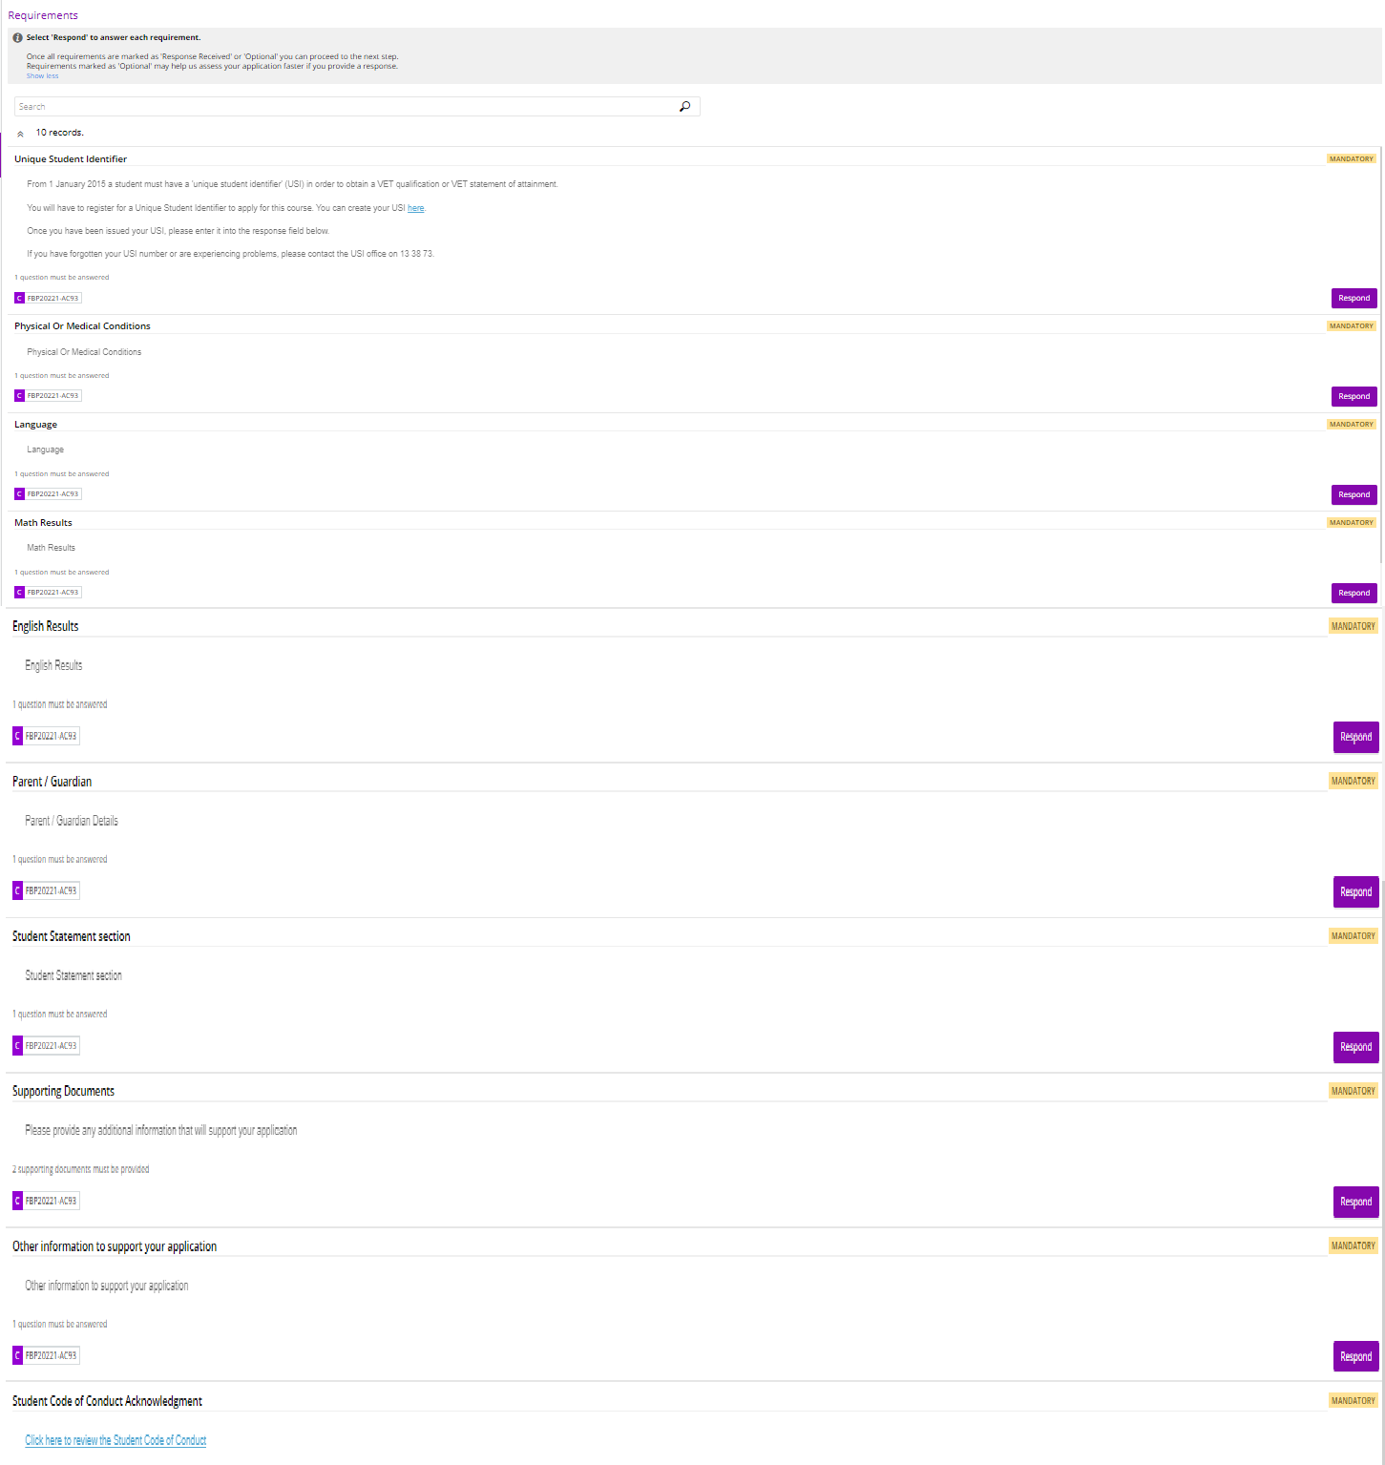

.

Not all fields in this section are mandatory. Mandatory fields are highlighted below.

To answer click and enter the required information. Once complete, click to continue.

**TIP!** Make sure you use the same name you created your USI with.



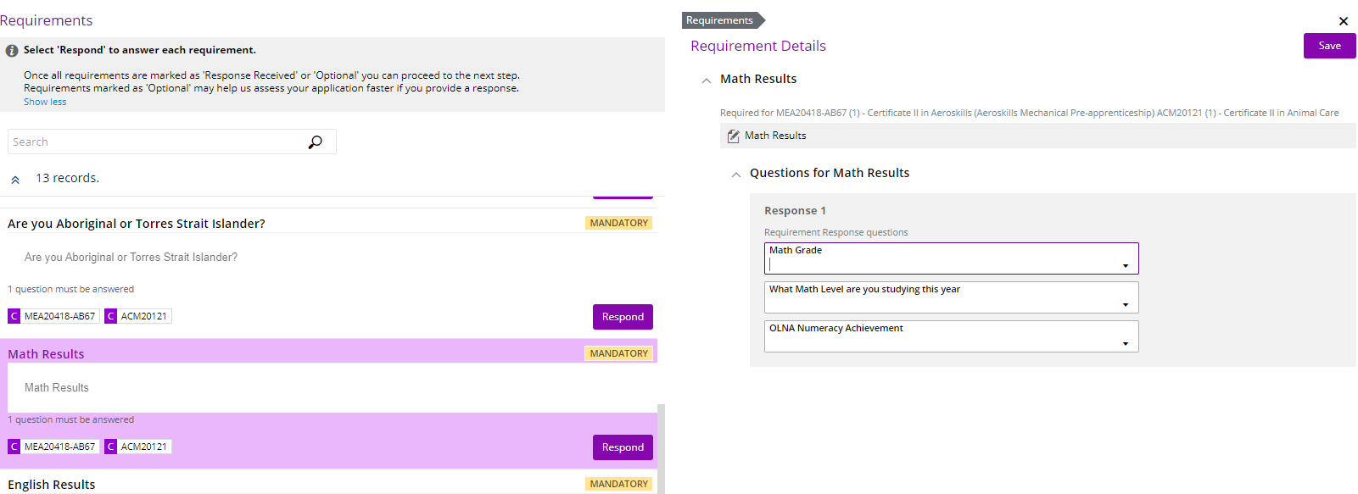



To answer, click on the

button which will prompt you to enter the required information.

Click



Once saved, the

completed. Click

icon in green will appear. ALL Mandatory fields will need to be.

once completed.

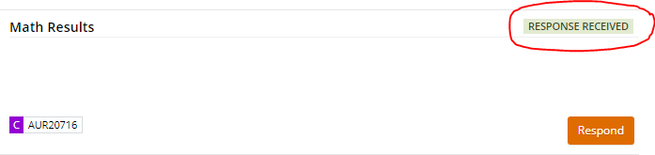

Note: Year 9 students can make an application for next year – i.e. use semester 1 reports and subject level for Maths and English as **“N/A-Year 9”** with your semester 1 grades.

You are now ready to review your application and submit. Please make sure you double check:

* You have used your legal name correctly.
* Date of birth is correct.
* Email address is correct.
* Course and campus selection are correct.

You can now click on  in the top right-hand corner of the screen.

**\*\*Please note once your application has been submitted it cannot be changed\*\***

A confirmation of your application will be sent to your email. Please check your junk folder. If you do not receive an email, you must contact South Metropolitan TAFE by emailing [vetdss@smtafe.wa.edu.au](mailto:vetdss@smtafe.wa.edu.au)

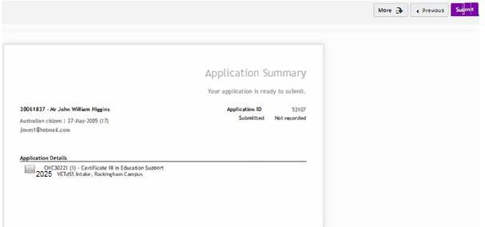

**Appendix**

### **Error #1**



### **Solution/Suggestion to Error #1**

Student may already have a student ID with SM TAFE but trying to register again for a new ID.

Or

System is picking up another student from the data base who may share similar name/DOB etc. If so, please contact [vetdss@smtafe.wa.edu.au](mailto:vetdss@smtafe.wa.edu.au)

Or

If one person is registering all of their students at the school, in between/after each registration for each new applicant the user has to Log Off – this should divert back to the log on screen and then the browser page be closed and a new browser page opened for each new applicant, the issues being experienced are likely due to caching issues.  If possible, the user uses Incognito mode for each new student record which will reduce

any caching issues and reduce likelihood of Error 1.

### **Error #2**

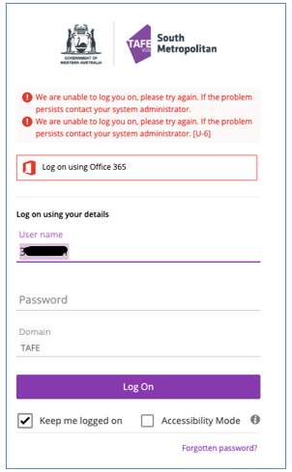

### 

### **Solution/Suggestion to Error #2**

Are you an existing student or an applicant? If existing student with active office 365 account, you do not have to log on using your details. Instead click on “Log on using Office 365” account.

**We suggest that you use your personal device (not a school device).**

**If you are using school device, browse the “Apply now” link using “browse as a Guest”.**

### **Error #3**



### **Solution/Suggestion to Error #3**

We suggest that you use your personal device (not a school device).

If you are using school device, browse the “Apply now” link using “browse as a Guest”. Or Alternatively, use the [Apply now - Link 2](https://login.microsoftonline.com/tafe.wa.edu.au/oauth2/authorize?client_id=0ec188d7-ff34-4dc9-a9f7-5fb41b8a1cdf&redirect_uri=https://smtafe.t1cloud.com/T1Default/CiAnywhere/Web/SMTAFE/LogOn&scope=user.read&response_type=code&login_hint=%5bStudentNumber%5d@tafe.wa.edu.au)

**Error #4** 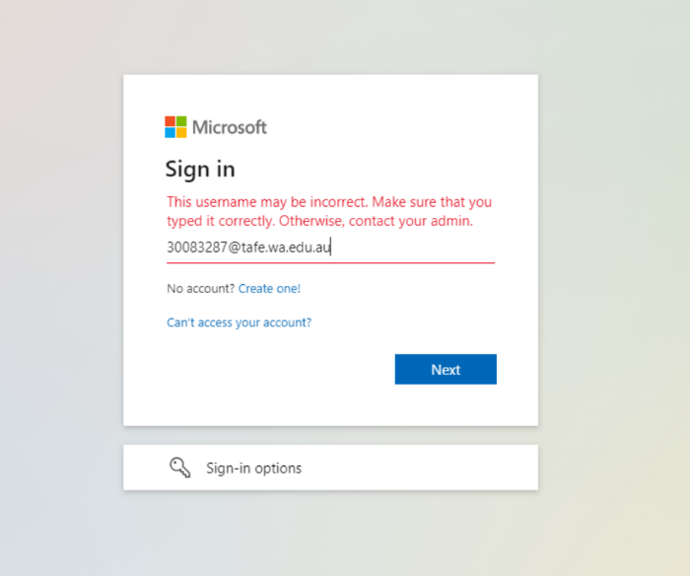

**We suggest that you use your personal device (not a school device).**

**If you are using school device, browse the “Apply now” link using “browse as a Guest”.**

Also Make sure that you are using SM TAFE ID and not other colleges ID or SCSA number

### **Error #5**

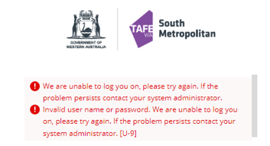

### **Solution/Suggestion to Error #5**

The U-9 error is occurring due to the student’s email being already registered for Office 365 with someone else. For example, if student might have registered an ID using Parent or Guardian office 365 account. Contact [vetdss@smtafe.wa.edu.au](mailto:vetdss@smtafe.wa.edu.au) and request for the email account to be updated to a different email address.

# **TIPS for Troubleshooting**

* Are you using Google Chrome? This is the preferred browser for this process.
* Have you logged out of your school account?
* At the end of the Application process, it is ESSENTIAL that you close the TAFE portal down and re-open it to avoid possible retention of data. Best practice is to close and then re-open the SMTAFE portal.
* We suggest that you use your personal device (not a school device).If you are using school device, browse the “Apply now” link using **“browse as a Guest”.**
* Is the correct **SM TAFE** student ID being used? This is an **8-digit number** that should look like this – 30XXXXXX (the first 2 numbers should be 30). If you have a Tafe ID from another TAFE, and these will not work in our system. This is **NOT** your Student ID for school and **NOT** your SCSA number.
* Has the “Forgotten Password?” function been used? If so, When you are resetting your own password, Please make sure to avoid using “TAFE” or “PASSWORD” or “Your name” or “Consecutive numbers””. [SM TAFE (Microsoft 365) Student Account | South Metropolitan TAFE](https://www.southmetrotafe.wa.edu.au/current-students/sm-tafe-microsoft-365-student-account)
* Currently enrolled SMTAFE students – have you updated your Password to new Student Password Standard? (New students would need to update their passwords once enrolled if the password created at registration does not meet this criteria)
* Does the password meet required parameters below?
* Minimum of 14 characters
* Contain a minimum of each of the following;
  + - * + Uppercase Letter, Lowercase Letter, and Number

eg; Fridaychange24

# **Useful links:**

[SM TAFE (Microsoft 365) Student Account | South Metropolitan TAFE](https://www.southmetrotafe.wa.edu.au/current-students/sm-tafe-microsoft-365-student-account)

[TAFE at school (VETDSS) | South Metropolitan TAFE (southmetrotafe.wa.edu.au)](https://www.southmetrotafe.wa.edu.au/secondary-school-students-vetdss)

[Apply now for VETDSS courses](https://smtafe.t1cloud.com/T1Default/CiAnywhere/Web/SMTAFE/f/$SC.STUAPPREG.MNT?suite=SM) Link 1

[Apply now - Link 2](https://login.microsoftonline.com/tafe.wa.edu.au/oauth2/authorize?client_id=0ec188d7-ff34-4dc9-a9f7-5fb41b8a1cdf&redirect_uri=https://smtafe.t1cloud.com/T1Default/CiAnywhere/Web/SMTAFE/LogOn&scope=user.read&response_type=code&login_hint=%5bStudentNumber%5d@tafe.wa.edu.au)

### **Logging back into your application**

Throughout your application, you can log back in to pick up where you left off. Please ensure you have your Log on SM **TAFE ID** Number (8-digit number sent to your email) and your password used when creating your profile by going back to Apply Now link.

Once logged in, click on ‘My Applications” where you will find your incomplete application.

# **Further information and assistance**

Please contact [vetdss@smtafe.wa.edu.au](mailto:vetdss@smtafe.wa.edu.au) if you require any more information or assistance with this guide.